**Subject: Optical Communication and Networks**

**Class/Sem: BE EXTC/VIII**

**Module 6**

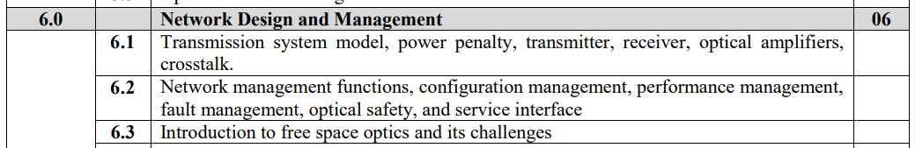

**Network Management:**

* Network management is an important part of any network.
* Carriers pay a lot of attention to minimizing life cycle costs, as opposed to worrying just about up-front equipment costs.

**Network Management Functions:**

Classically, network management consists of several functions, all of which are important to the operation of the network:

**1. Performance management** deals with monitoring and managing the various parameters that measure the performance of the network. Performance management is an essential function that enables a service provider to provide quality-of-service guarantees to their clients and to ensure that clients comply with the requirements imposed by the service provider. It is also needed to provide input to other network management functions, in particular, fault management, when anomalous conditions are detected in the network.

**2. Fault management** is the function responsible for detecting failures when they happen and isolating the failed component. The network also needs to restore traffic that may be disrupted due to the failure, but this is usually considered a separate function.

**3. Configuration management** deals with the set of functions associated with managing orderly changes in a network. The basic function of managing the equipment in the network belongs to this category. This includes tracking the equipment in the network and managing the addition/removal of equipment, including any rerouting of traffic this may involve and the management of software versions on the equipment.

Another aspect of configuration management is connection management, which deals with setting up, taking down, and keeping track of connections in a network. This function can be performed by a centralized management system. Alternatively, it can also be performed by a distributed network control entity. Distributed network control becomes necessary when connection setup/take-down events occur very frequently or when the network is very large and complex.

Finally, the network needs to convert external client signals entering the optical layer into appropriate signals inside the optical layer. This function is adaptation management.

**A. Connection management:**

* Centralized management system-setting up, taking down, and keeping track of connections in a network.
* Distributed network control-setup/take-down events occur very frequently or when the network is very large and complex.

**B. Adaptation management:**

* Network needs to convert external client signals entering the optical layer into appropriate signals inside the optical layer.

**4. Security management** includes administrative functions such as authenticating users and setting attributes such as read and write permissions on a per-user basis. From a security perspective, the network is usually partitioned into domains, both horizontally and vertically. Vertical partitioning implies that some users may be allowed to access only certain network elements and not other network elements.

* For example, a local craftsperson may be allowed to access only the network elements he is responsible for and not other network elements. Horizontal partitioning implies that some users may be allowed to access some parameters associated with all the network elements across the network.
* For example, a user leasing a lightpath may be provided access to all the performance parameters associated with that lightpath across all the nodes that the light path traverses. Security also involves protecting data belonging to network users from being tapped or corrupted by unauthorized entities. This part of the problem needs to be handled by encrypting the data before transmission and providing the decrypting capability to legitimate users.

**5. Accounting management** is the function responsible for billing and for developing lifetime histories of the network components. This function is the same for optical networks.

**Optical Safety:**

The semiconductor lasers used in optical communication systems are relatively low-power devices; nevertheless, their emissions can cause serious damage to the human eye, including permanent blindness and burns. The closer the laser wavelength is to the visible range, the more damage it can do, since the cornea is more transparent to these wavelengths. For this reason, systems with lasers must obey certain safety standards. Systems with lasers are classified according to their emission levels, and the relevant classes for communication systems . In some cases, these safety issues can limit the allowable optical power used in the system.

* A Class I system cannot emit damaging radiation. The laser itself may be a high-power laser, but it is prevented from causing damage by enclosing it in a suitably interlocking enclosure. The maximum power limit in a fiber for a Class I system is about 10 mW (10 dBm) at 1.55 μ m and 1 mW(0 dBm) at 1.3 μ m. Moreover, the power must not exceed this level eve n under a single failure condition within the equipment. A typical home CD player, for example, is a Class I system.
* A Class IIIa system allows higher emission powers—up to 17 dBmin the 1.55 μ m wavelength range—but access must be restricted to trained service personnel. Class IIIa laser emissions are generally safe unless the laser beam is collected or focused onto the human eye.
* A Class IIIb system permits even higher emission powers, and the radiation can cause eye damage even if not focused or collected. Under normal operation, optical communication systems are completely “enclosed” systems—laser radiation is confined to within the system and is not seen outside. The problem arises during servicing or installation, or when there is a fiber cut, in which case the system is no longer completely.

enclosed and emission powers must be kept below the levels recommended for that particular system class. Communication systems deployed in the enterprise world must generally conform to Class I standards since untrained users are likely to be using them. Systems deployed within carrier networks, on the other hand, may likely be Class IIIa systems, since access to these systems is typically restricted to trained service personnel. The safety issue thus limits the maximum power that can be launched into a fiber.

For single-channel systems without optical power amplifiers using semiconductor lasers, the emission levels are small enough (− 3 to 0 dBm typically) that we do not have to worry much about laser safety. However, with WDM systems, or with systems using optical power amplifiers, we must be careful to regulate the total power into the fiber at all times.

**Optical Layer Services and Interface:**

The optical layer offers light paths to other higher layers such as the SONET/SDH, IP/MPLS, and Ethernet layers. It also provides light paths to the electronic layer of the Optical Transport Network (OTN). In this situation, the optical layer acts as a server layer, and the higher layer acts as the client layer that makes use of the services provided by the optical layer.

From this perspective, we need to specify clearly the service interface between the optical layer and its client layers. The key features of a managed light path service or optical interface are as follows:

1. As per the requirements of client layers the light paths must be added or removed.
2. The amount of bandwidth required for the light path is decided by the client layers.
3. An adaptation function required at the input and output of the optical network that converts client signals to the signals compatible with the optical layer. The transponder offers this function is typically provided by transponders.
4. The light paths should provide a guaranteed level of performance, typically BER which is 10-12.
5. Almost all light paths are bidirectional. But, if more bandwidth is required in one direction it can be desirable to support unidirectional light paths.
6. A multicasting or a drop-and-continue function must be supported, Multicasting function is used to support distribution of video or conferencing information. The drop-and-continue function is useful for network survivability when several rings are interconnected.
7. In order to meet the jitter requirements, 3R regeneration can be used in the network.
8. Maximum allowed propagation delay should be considered while designing the light paths;
9. Extensive fault management must be supported so that it is possible to report the root-
10. cause alarms and perform the sufficient isolation of faults in the network.

In order to deliver of these services a control and management interface between the optical layer and the client layer is required.

**Functions of an optical interface:**

* Optical layer interface enables the client to identify the set of light paths that are to be set up or taken down and set the service parameters related with those light paths.
* The interface enables the optical layer to give performance and fault management information to the client layer. This interface can take on one of two surface.

A separate management system communicates with the element management system (EMS) and the EMS then manages the optical layer. The current operation method works well as long as light paths are set up quite infrequently and remain nailed down for long period of time.

In large networks, it is possible in the future, that the light paths are provisioned and taken down more dynamically. In this situation, it is required to specify a signaling interface between the optical layer and the client layer.

**Free Space Optics (FSO):**

Free space optics is a communication system where free space acts as medium between transceivers and they must be in LOS for successful transmission of optical signal. FSO Communication medium can be air, outer space, or vacuum. There is no need of the optical fiber cable.

FSO is an optical communication technique which broadcasts light in free space such as air, vacuum or space, to transfer data wirelessly. It offers high data rates up to 2.5 Gbps over a range of 100 m to a few kilometers. It has ability to replace the traditional means of communications in a wide variety of applications. FSO system includes an optical transceiver at both ends in order to provide full duplex (bidirectional) capability. FSO is a line of sight (LOS) technology, where data, voice, and video communication is achieved with maximum 10 Gbps of data rate by full duplex (bidirectional) connectivity.

**Characteristics:**

- An effective FSO system must have the following characteristics :

* It should operate at higher power levels for longer distance.
* High speed modulation is important for high speed FSO systems.
* FSO system design should have small footprint and low power consumption because of its maintenance.
* It should operate over wide temperature range and the performance degradation will be less for outdoor systems.
* Mean time between failures (MTBF) of FSO system should be more than 10 years.

**Block Diagram of FSO:**

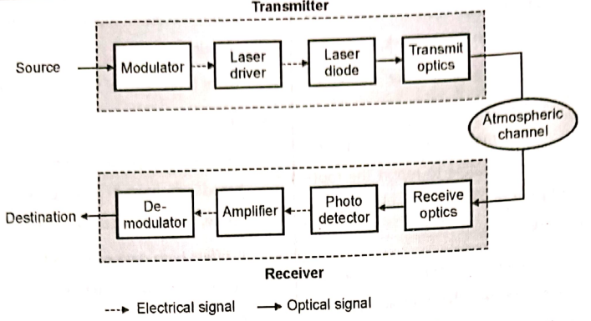

FSO system consist of:

1. Transmitter.

2. Atmospheric channel.

3. Receiver:

**1. Transmitter:**

The transmitter converts the information to a signal form which is suitable for transmission over the atmospheric channel. The role of modulator is to modulate the data for transmission by using various modulation techniques. The function of modulator is to modulate the information signal and drive the laser driver.

Laser diode is preferred because it has quality of high pointedness and consistency that its beam displays. The laser diode converts the information in the electrical domain to an optical signal. The function of transmit optics is to collect the laser light and direct it towards the receiver.

**2. Atmospheric Channel:**

In FSO system, the atmospheric channel can be vacuum, atmosphere, or water. In the atmospheric channel, the signal faces random attenuation due to fog, haze, cloud and rain. Atmospheric turbulence in FSO link is the main limiting factor for its performance. Atmospheric turbulence causes the degradation of the optical beam of transmission

**3. Receiver:**

The incident optical signal is captured by the receive optics, and it send this signal on the photodetector. A photodetector converts the received optical signal to electrical signal. Then the amplifier amplifies the signal and increases the SNR. Modulation and demodulation of the signal takes place in electrical form. Demodulation of received signal takes place and the signal is formed in the preferred form at the destination.

**Applications of FSO :**

* **Outdoor wireless access:** Wireless service providers can use FSO for communication and no license is required to use the FSO.
* **Storage Area Network (SAN):** FSO links can be used to form a SAN. SAN is a network which provides access to consolidated, block level data storage.
* **Last-mile access:** It is high speed link and used in last mile access and to bypass local-loop systems of other types of networks.
* **Enterprise Connectivity:** FSO systems can be installed easily. It is used in interconnecting LAN segments to connect two buildings or other property.
* **Fiber backup:** FSO can provide a backup link in case of failure of transmission through fiber link.
* **Metro-network extensions:** FSO system can be installed in less time and connection of the new networks and core infrastructure is easily done. It can be to complete SONET rings.
* **Backhaul:** FSO can carry the traffic of cellular telephone from antenna towers back to the PSTN with high speed and high data rate.
* **Service acceleration:** It provides instant service to customers.
* **Bridging WAN Access:** FSO is useful in WAN where it supports high speed data services for mobile users and small satellite terminals and it acts as a backbone for high speed trunking network.
* **Communication:** FSO can be used to communicate between point-to- point links (two buildings, two ships), - point-to-multipoint links (from aircraft to ground or satellite to ground) and short and long reach communication.
* **Military access:** FSO is a secure and undetectable system hence it can connect large areas safely with minimum planning and deployment time. Hence FSOs are suitable for military applications.

**Merits of FSO:**

1. FSO systems delivers better speed than broadband systems.
2. Installation of FSO is easy and it takes less time to install FSO at normal locations.
3. It requires very low initial investment.
4. FSO system do not need spectrum license or frequency coordination between users.
5. It is a secure because of line of sight operation and no need of security system upgradation.
6. FSO systems are immune to radio frequency interference.
7. The transmission in FSO link is not affected by electromagnetic and radio-magnetic interference.
8. It offers low power usage per transmitted bit.
9. FSO provides high bandwidth.
10. FSO has flexible rollouts.
11. FSO is a high speed communication system as transmission involves optical beam.
12. It has low cost and simple deployment.
13. FSO system low power usage per transmitted bit, low bit error rates, full duplex operation.
14. No need to connect the transmitter and receiver through a waveguide as the transmission is free space.

**Disadvantages of FSO:**

1. Spreading loss in FSO link is higher and there is atmospheric loss due to water and carbon dioxide molecules.
2. High power consumption.
3. It is less secure as compared to OFC.
4. Transmitter ‘and receiver must be in LOS (Line of Sight) to each other for FSO operation.
5. The FSO transmitted signal can be blocked due to trees, animals, tall buildings and other atmospheric conditions.
6. Birds and scintillation results in beam interruptions. Hence availability of FSO link depends on weather conditions.

**Challenges in FSO:**

**Physical obstructions :**

The flying birds, trees and tall buildings can momentarily block a single beam, when it come into view of line of sight (LOS) of transmission of FSO system.

**Scintillation :**

The temperature variations results in the fluctuations in amplitude of the signal which causes “image dancing” at the FSO receiving end.

**Geometric losses :**

Geometric losses which can be called optical beam attenuation are induced due to the spreading of beam and reduced the power level of signal as it travelled from transmitted end to receiver end.

**Absorption :**

A FSO system is directly affected by absorption as the power density of the optical beam is reduced.

**Atmospheric turbulence :**

The atmospheric disturbance occurs due to structure of weather and environment. Atmospheric turbulence causes the degradation of the optical beam of transmission.

**Atmospheric attenuation / Weather conditions :**

Atmospheric attenuation causes due to fog and haze and it depends on dust and rain. In a FSO transmission. Attenuation depends on several weather conditions like fog, rain, haze, smoke, sandstorms, link, atmosphere is the medium of clouds etc.

**Difference between FSO and Fiber Optic Communication**

